DC Current and Voltage Measurement

Overview
The DC current and voltage measurement board is designed for use in battery and other DC systems up to a maximum of 70V to measure DC voltage and current.
The board has two communication interfaces that are both active at all times. The first is a Modbus interface employing RS485 communication at 9600 Baud. The second is a CAN bus interface running at 250kBaud. CAN is provided via a dual RJ45 connector for simple connection to multiple devices with each port fully connected as a straight through bus.

DC Measurement Side
The DC measurement side has a 4 pin pluggable screw terminal connector on 3.81mm pitch on the edge of the board. Connections are to positive and negative battery terminals with two connections to a series resistor placed in the positive battery connection with a resistance calculated to provide approximately 75mV of drop at full scale current. Current measurement is bidirectional thus measuring charging and discharging current as positive and negative values.
Power for the onboard processor and the measurement circuitry is taken from the DC supply inputs.

Communication Side
The communication side of the module is fully isolated from the DC measurement side and power is provided by an isolated DC-DC converter. Only the communication connections are required with no external power connection necessary.

RS485 – Modbus
Connection is via 3 three pin pluggable screw terminal connector with a 3.81mm pitch on the edge of the board. The interface is fully isolated from the DC measurement section but is NOT isolated from the CAN Bus connection. Normally, only one of these communications systems would be used in an installation. Modbus communication is set at 9600Baud with 8 bits and no parity.
The device responds as a Modbus slave at an address defined by the first three jumpers on the board. The base address is defined here…
LK0 | LK1 | LK2 | Base Address
Present | Present | Present | 0x010
Omitted | Present | Present | 0x014
Present | Omitted | Present | 0x018
Omitted | Omitted | Present | 0x01D
Present | Present | Omitted | 0x020
Omitted | Present | Omitted | 0x024
Present | Omitted | Omitted | 0x028
Omitted | Omitted | Omitted | 0x02C

There are three input registers used to obtain the current values measured by the device.
Input Register | Content
0 | Volts – resolution = 10mV
1 | Amps (High word) – High word of a 32 bit signed integer with a resolution of 10mA
2 | Amps (Low word) – Low word of a 32 bit signed integer with a resolution of 10mA

Calibration is performed by setting the high and low voltage and current values measured in real time. These are set using the following holding registers.
Holding Register | Function
3 | Low Voltage
4 | High Voltage
6 & 6 | Low Current
7 & 8 | High Current

Writing to the appropriate register will cause the device to take the relevant measurement and assign the value provided to it. When both high and low values are set the constant and multiplier are calculated which are then used to calculate the values returned.
Calibration procedure is to apply a low voltage measured with a reference meter to the device and set register 3 to the measured value multiplied by 100 from the reference meter. Next, apply a high voltage using the same procedure but write to register 4.
For current, a similar procedure should be followed except the values written should be 32 bits written to two registers using a multiple register write command.
When the calibration values are written they are stored tot he flash memory on the STM32F072 processor on the device so they will not be lost when power is removed.
CAN Bus communication is always active running at 250kBaud. Values are transmitted as follows.
LK0 | LK1 | LK2 | CAN ID | Value
Present | Present | Present | 0x050 | Voltage
Present | Present | Present | 0x051 | Current
Omitted | Present | Present | 0x054 | Voltage
Omitted | Present | Present | 0x055 | Current
Present | Omitted | Present | 0x058 | Voltage
Present | Omitted | Present | 0x059 | Current
Omitted | Omitted | Present | 0x05D | Voltage
Omitted | Omitted | Present | 0x05E | Current
Present | Present | Omitted | 0x060 | Voltage
Present | Present | Omitted | 0x061 | Current
Omitted | Present | Omitted | 0x064 | Voltage
Omitted | Present | Omitted | 0x065 | Current
Present | Omitted | Omitted | 0x068 | Voltage
Present | Omitted | Omitted | 0x069 | Current
Omitted | Omitted | Omitted | 0x06C | Voltage
Omitted | Omitted | Omitted | 0x06D | Current

Frame content
ID | Int32-0 | Int32-1 | Byte 4-7 | Int32 4
0x50 | Calculated Volts x 100 | Raw | Unused | Unused
0x51 | Calculated Amps x 100 | Raw | Unused | Unused

DC Input connections
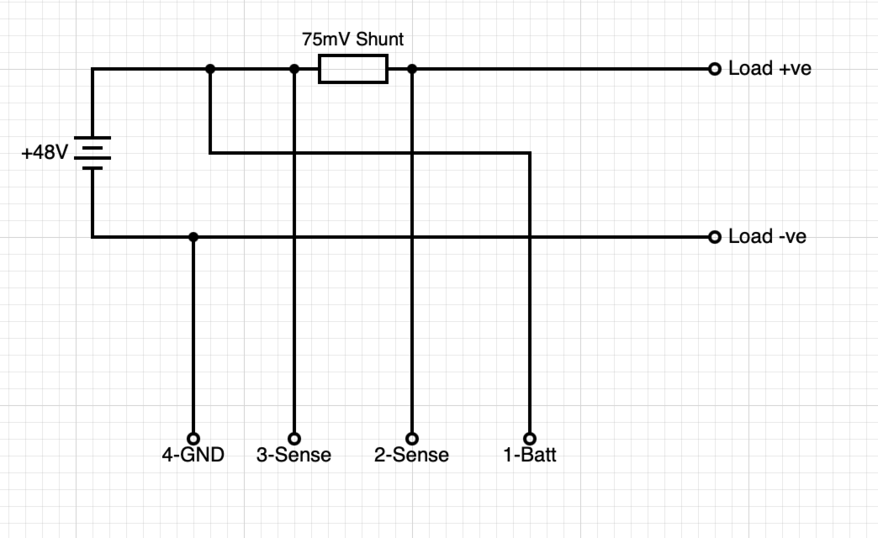
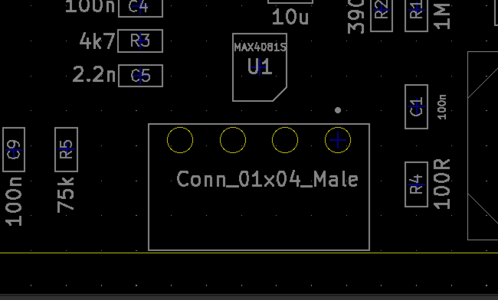

RS485 Connections
Use the 3 pin pluggable screw terminal to connect to the RS485 bus.
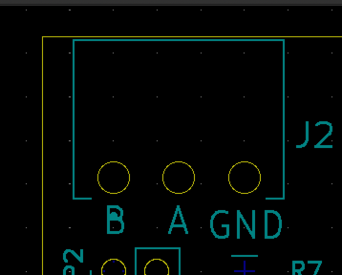

CAN Bus Connections
CAN Bus connection is via two RJ45 connectors. The connections are identical on both connectors and all pins are connected through to allow easy chaining of devices using readily available Ethernet style patch cables.
